DOCUMENT 09 — Database Schema & Data Model
Visionary Internal · v1.0 · Postgres (state) · Neo4j (KG) · Qdrant (memory) · Redis (hot)

1. Entity map
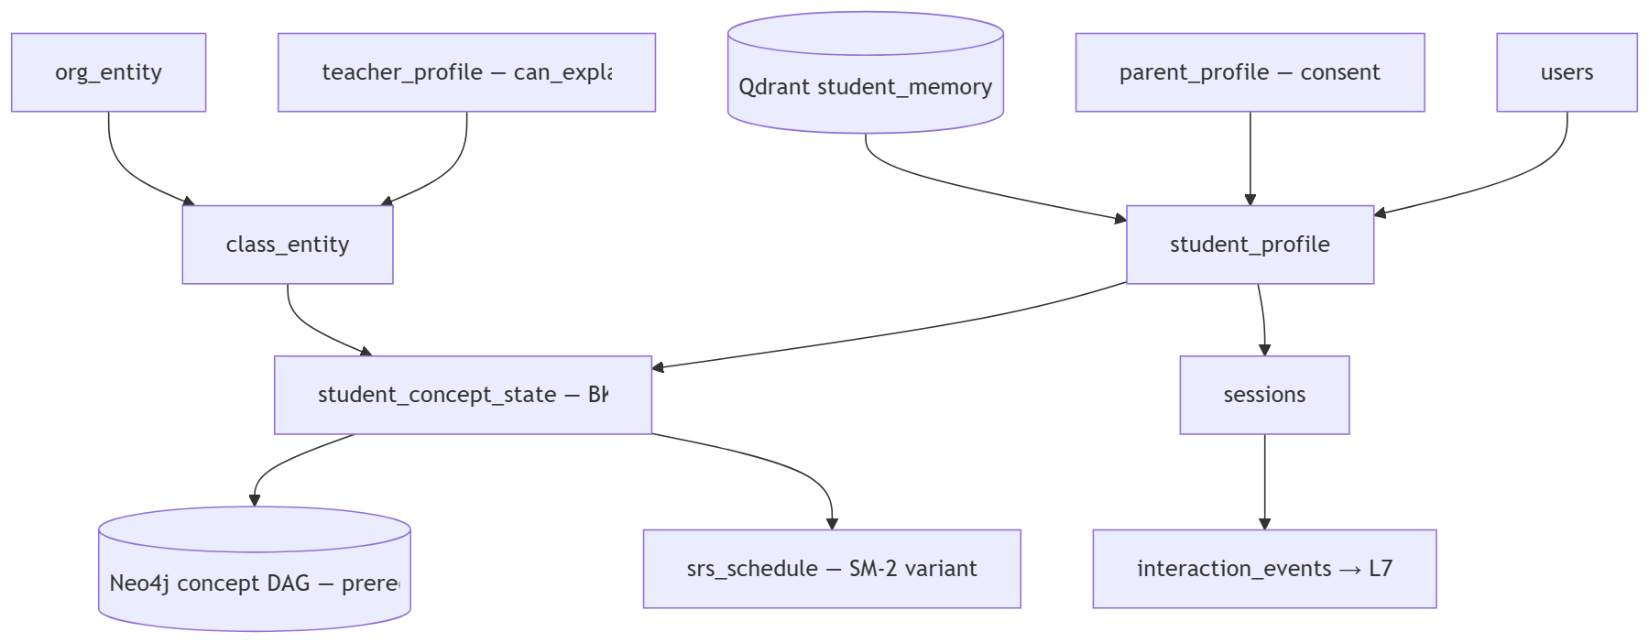

2. Core tables (Postgres)

Table | Key columns | Notes
student_profile | user_id, board, class_level, primary_language, target_exam, device_tier, parent_id | onboarding writes
student_concept_state | student_id, concept_id, p_mastered, p_guess, p_slip, p_transit, error_class, attempts, last_seen | BKT posterior; Redis-cached (read ≤50ms)
class_entity / class_enrollment | class_id, teacher_id, student_ids, subject, academic_year | teacher aggregate view
teacher_profile | teacher_id, subject, can_explain(jsonb), class_ids | SCM variant P(can_explain)
parent_profile / consent | parent_id, child_ids, report_day, consent_state, expiry | DPDP-scoped; revocation cuts read in ≤1 session
srs_schedule | student_id, concept_id, next_review, interval, ease | forgetting-curve scheduler
artifacts | owner_id, type, payload, mastery_signal, share_state | BUILD output; teach = strongest mastery signal
interaction_events | append-only, PII-scrubbed | L7 source of truth (from user #1, R1)

3. Rules
- KG nodes carry prerequisites[], difficulty, has_3d_visual, exam_weightage, is_in_current_syllabus, medium_of_instruction, data_source_url, last_verified_date.
- Mastery read path = Redis first (R3); Postgres durable. Qdrant namespaces per student.
- Retention per DPDP; erasure cascades to SCM/memory/artifacts on request (≤30 days).

OKF
KF1 BKT update <100ms post-response · KF2 prerequisite trace returns root-cause concept · KF3 consent revocation effective within 1 session · KF4 erasure completes ≤30 days · KF5 zero PII in interaction_events.

